FRE-GY 6123 Financial Risk Management, Fall 2026
Homework 1
Name: Rajvardhan Pawar NetID: rsp9234
Assumptions and VaR calculation method
- Data: 522 daily yields for the 2-year and 10-year Treasury from 1-Oct-24 to 30-Sep-26, which gives 521 daily changes (the "shocks") in bp. I use every day in the window, including the days where a yield did not change.
- Mean and standard deviation are sample statistics over the full window (STDEV.S, so n-1). "Within k SD" means the distance from the mean is at most k times the SD.
- PV01 (-dP/dY) is the Bloomberg risk number and d2P/dY2 is the value in the spreadsheet (Bloomberg convexity x full price / 100): 1.878 and 0.0449 for the 2-year, 7.382 and 0.6908 for the 10-year, all per 100 face. I keep them fixed. Position sizes are face amounts.
- Repricing uses the second-order formula from the spreadsheet, as a % of par: price change = -PV01 x (yield change in bp)/100 + 0.5 x d2P/dY2 x (yield change in bp)^2/10000. I treat PV01 as a positive number, so a long position loses when its yield goes up. Dollar P&L = face x price change / 100.
- VaR method: historical simulation. I take each of the 521 historical pairs of 2-year and 10-year changes, apply it to today's position as an absolute move in bp, reprice both legs with the formula above and add them up. This keeps the actual co-movement of the two yields and does not assume the changes are normal.
- The 99% 1-day VaR is minus the 1st percentile of the 521 simulated P&Ls (Excel PERCENTILE.INC, which interpolates between the 6th and 7th worst days). I report it as a positive dollar loss.
- Horizon is one day, every historical day has the same weight, and I ignore carry, roll-down and financing.
All calculations are in the Excel file (sheets Summary, Q1-Q4 Stats, Q5-Q7 VaR and Q8 VaR Graph).
Question 1
 | Mean (bp) | SD (bp) | Days within 1 SD | % within 1 SD | Days within 2 SD | % within 2 SD
2-year shocks | 0.25 | 4.88 | 385 of 521 | 73.90% | 496 of 521 | 95.20%
10-year shocks | 0.30 | 4.85 | 379 of 521 | 72.74% | 491 of 521 | 94.24%
Normal distribution |  |  |  | 68.27% |  | 95.45%

2-year: 73.90% of the daily changes are within 1 SD of the mean and 95.20% are within 2 SD. 10-year: 72.74% are within 1 SD and 94.24% are within 2 SD.
If the changes were normal I would expect 68.27% and 95.45%. Both series have more days close to the mean than a normal distribution and slightly fewer inside 2 SD, so they are more peaked in the middle with somewhat fatter tails. This is strongest for the 2-year: its excess kurtosis is 2.88 against 0.67 for the 10-year. Most days are quiet, and then there are a few very large moves (the biggest 2-year changes are -27.4 bp and +21.8 bp, both more than 4 SD). 5 of the 2-year changes are more than 3 SD from the mean, where a normal distribution would give about 1.4. This matters later because a VaR based on the normal distribution would understate the tail.
Question 2
The sample correlation between the 2-year and 10-year daily changes over the full window is 0.8204 (521 days, Excel CORREL).
The two yields move in the same direction most of the time, which is what I would expect since both react to the same news on rates and the economy. But the correlation is clearly below 1, so there is also a part of the 2-year move that is not shared with the 10-year (the curve steepening or flattening). That part is what makes the hedges in Questions 5 to 8 imperfect.
Question 3
Conditional expected value | Value (bp) | Days in the condition
E[2-year shock | 10-year shock >= 0] | 2.94 | 286
E[10-year shock | 2-year shock >= 0] | 3.22 | 275
E[2-year shock | 10-year shock < 0] (for comparison) | -3.03 | 235
E[10-year shock | 2-year shock < 0] (for comparison) | -2.97 | 246

E[2-year shock | 10-year shock >= 0] = 2.94 bp and E[10-year shock | 2-year shock >= 0] = 3.22 bp.
These numbers tell me about the correlation once I compare them with what I would get if the two shocks were unrelated. In that case, knowing that the 10-year went up would tell me nothing about the 2-year, and the conditional mean would just be the overall mean of 0.25 bp. Instead it is 2.94 bp, about 0.6 SD of a 2-year change, and it flips to -3.03 bp on the days when the 10-year fell. So the sign of one shock moves the expected value of the other by a lot, and in the same direction. That is positive correlation, and I can see it without computing the correlation coefficient.
The size also lines up with Question 2. For joint normal shocks with mean close to zero, E[X | Y >= 0] = correlation x SD(X) x sqrt(2/pi), which is about 0.80 x correlation x SD(X). With a correlation of 1 the 2-year number would be about 3.89 bp and with zero correlation it would be about 0. Backing out the correlation from my two numbers gives roughly 0.76 and 0.83, or about 0.73 and 0.79 if I first take out the small positive means. That is in the same range as the 0.82 from Question 2. The two are not identical because this measure only uses the sign of the conditioning shock and the data are not exactly normal. The conditional means also show that the relationship is about the same on up days and down days, which a single correlation number does not show.
Question 4
There are 96 days on which both the 2-year and the 10-year change are more than 1 SD away from their mean. The sample correlation on those days is 0.9459.
For reference, the 2-year change is more than 1 SD from its mean on 136 days and the 10-year on 142 days, and 96 of those are the same days. The correlation goes up from 0.82 over the whole window to 0.95 on the big-move days. On all 96 days the two yields moved in the same direction (44 days both up, 52 days both down, 0 days opposite).
I do not think this shows that the correlation is really higher on big days. Keeping only the days where both moves are large throws away the middle of the scatter plot and leaves two clusters, one in the up-up corner and one in the down-down corner, and two clusters like that give a correlation close to 1 almost automatically. As a check, for joint normal shocks with a constant correlation of 0.82 the same filter gives a correlation of about 0.96 and practically no days with opposite moves, which is what I see here (0.95 and zero days). So the jump from 0.82 to 0.95 is mostly a selection effect. What I take from it is that a correlation measured only on large-move days cannot be compared directly with the full-sample number.
Question 5
I would sell about $78.62 million face of 2-year notes.
The PV01 of the 10-year is 7.382 per 100 face, which is $738.2 per bp for each $1 million face, so the long $20 million position has a DV01 of 20 x 738.2 = $14,764 per bp. The 2-year has a PV01 of 1.878, or $187.8 per bp per $1 million. To cancel the 10-year exposure I need 14,764 / 187.8 = 78.62, so $78.62 million of 2-year notes sold short. That is a hedge ratio of 7.382 / 1.878 = 3.93 to 1, and the net PV01 of the combined position is zero. This only makes the position neutral to a move where both yields change by the same number of bp.
Question 6
The 2-year leg has a DV01 of 15 x 187.8 = $2,817 per bp, so the 10-year leg needs 2,817 / 738.2 = $3.816 million face. Total DV01 of the portfolio is $5,634 per bp.
Does equal PV01 mean equal risk? No. PV01 only tells me how much each leg loses for a 1 bp rise in its own yield. Risk also depends on how many bp each yield actually moves in a day, on how fat the tails are, and on how the two yields move together. Matching PV01 would only match risk if the 2-year and 10-year yields had the same distribution of daily changes.
Each leg on its own | 2-year leg | 10-year leg
DV01 ($ per bp) | 2,817 | 2,817
Daily SD of the yield change (bp) | 4.88 | 4.85
Excess kurtosis of the yield change | 2.88 | 0.67
Daily SD of P&L ($) | 13,747 | 13,667
Stand-alone 99% 1-day VaR ($) | 34,654 | 34,116
Worst 1-day loss in the window ($) | 61,251 | 52,770
Share of portfolio P&L variance | 50.2% | 49.8%

In this sample the two legs do come out close: the daily SDs of the two yields are almost the same (4.88 bp and 4.85 bp), so the P&L volatility, the stand-alone VaR and the variance shares are all roughly 50/50. But that is a result of this particular two-year window, not something that equal PV01 guarantees. In a period where the 2-year is more volatile than the 10-year (or the other way round) the same PV01 would carry different risk. Even here the legs are not identical in the tail: the 2-year shocks have much fatter tails, and the worst day costs $61,251 on the 2-year leg against $52,770 on the 10-year leg. The legs also sit on different parts of the curve, so they respond differently to a steepening or a flattening, and the 10-year has more convexity per unit of PV01.
Question 7
For $15 million 2-year notes plus $3.816 million 10-year notes, the 99% 1-day VaR is about $66,844.
This is the historical simulation described at the top: 521 scenarios, each leg repriced with the second-order formula, and VaR read off as minus the 1st percentile of the daily P&L. A few numbers around it:
- The 5th and 6th worst days lose $68,374 and $67,342, so using one of those as the VaR instead would raise the answer by about 2% at most. The worst day in the window is 04-Oct-24 with a loss of $95,143, when the 2-year rose 21.8 bp and the 10-year 12.1 bp.
- VaR divided by the total DV01 is 11.9 bp, so the VaR is about the loss from a parallel rise of 12 bp in both yields.
- A normal approximation (2.3263 x the daily P&L SD of $26,156, with the mean set to zero) gives $60,847, which is lower than the historical number. That fits the fat tails from Question 1.
- With only the first-order PV01 term the VaR would be $67,101. The convexity term lowers it by about $257, which is small because one-day yield moves are small.
- The two stand-alone VaRs add up to $68,770, so putting the legs together saves only about $1,926. Both legs are long and the two yields are highly correlated (0.82), so there is little diversification.
Question 8
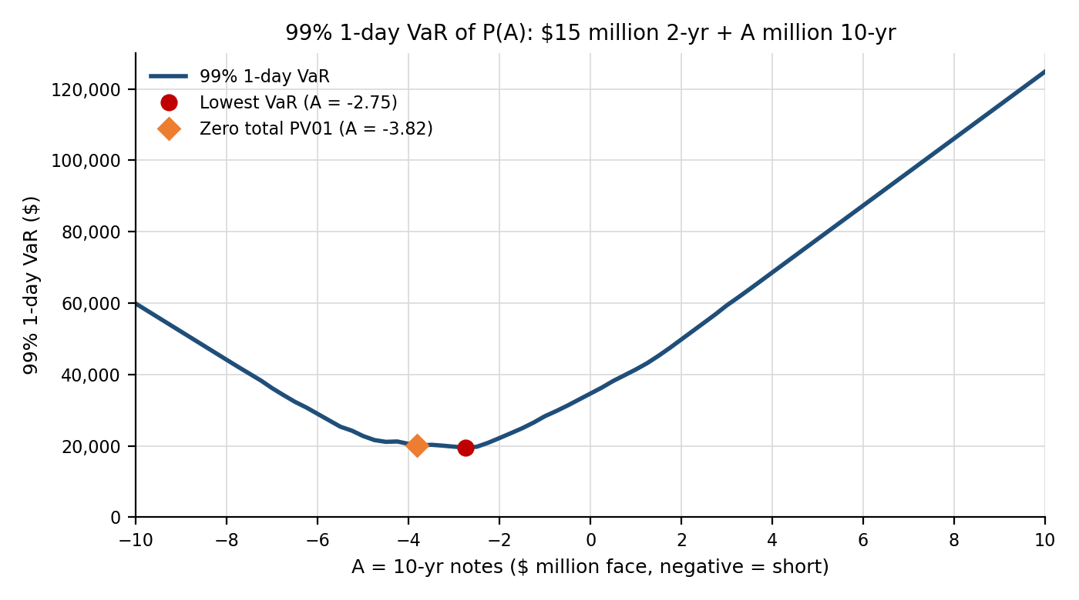
Figure: 99% 1-day VaR of P(A) for A from -10 to +10 ($ million face of 10-year notes, step 0.25). The same chart is on the Q8 VaR Graph sheet.
Point on the curve | A ($ million face) | 99% 1-day VaR ($)
Lowest VaR on the grid | -2.75 | 19,533
Zero total PV01 | -3.816 | 20,106
Minimum-variance hedge (beta x zero-PV01 amount) | -3.148 | 19,945
No 10-year position (A = 0) | 0.00 | 34,654

No, the lowest VaR is not at the zero-PV01 point. The total PV01 is zero at A = -3.816 (short $3.816 million of 10-year notes), where the VaR is $20,106. The lowest VaR on my grid is at A = -2.75, where it is $19,533. So the best hedge uses fewer 10-year notes than the PV01-neutral hedge.
The reason is that zero PV01 only protects against a parallel shift, where both yields move by the same number of bp. In the data they do not move one for one. The regression beta of the 2-year change on the 10-year change is 0.825 (the correlation of 0.82 times the ratio of the SDs, which is close to 1), so on average the 2-year moves a little over 0.8 bp when the 10-year moves 1 bp. Shorting the full PV01-neutral amount over-hedges. The variance-minimising hedge is 0.825 x 3.816 = $3.15 million short, and the VaR-minimising point is in the same area. It is not exactly the same number because VaR is a tail percentile and not a variance, so it depends on what happened on the handful of worst days.
Two more things I notice in the graph. First, the curve is quite flat between about A = -4 and A = -2.5 (VaR stays around $20,000), so the exact location of the minimum is not very precise and the zero-PV01 hedge costs only about $573 of extra VaR. Second, the VaR never gets close to zero. Even at the best A it is 56% of the unhedged VaR of $34,654. With a correlation of 0.82, the part of the 2-year move that is unrelated to the 10-year is sqrt(1 - 0.82^2) = 57% of its SD, and no amount of 10-year notes can hedge that curve risk. To the right of the minimum the VaR rises steadily: first the short 10-year hedge is being taken off, and past A = 0 the long 10-year notes add to the same exposure to rates going up.

